
CSA15 – CLOUD COMPUTING AND BIG DATA ANALYTICS

ASSIGNMENT 1 – CO1
Design, Analyse and Validate a Cloud-Based Solution for Migrating a Legacy University Management System
CO1: Apply cloud computing technologies including hardware–software evolution, virtualization, web services, and service models to develop cloud-based solutions.

Field | Details | Field | Details
Student Name | VIDULA R | Register Number | 192511270
Department / Section | BE CSE | Academic Year / Semester | 2ND YR
Faculty Name | DR ANTONY JOSEPH RAJA | Nature of Assignment | Individual
Duration | 1 Week | Total Marks | 50
Submission Date |  | Evaluation Date

MARK SHEET (Rubric-based evaluation)
Task | Title | Max | Awarded | Evidence / evaluation focus
1 | Introduce Cloud Computing | 3 |  | Definition; characteristics; deployment models; scenario mapping
2 | Trace Evolution and Hardware Evolution | 3 |  | Timeline; hardware evolution; relevance to university
3 | Analyse Internet Software Evolution | 3 |  | Web/software evolution; SOA; APIs; scenario relevance
4 | Apply Server Virtualization | 5 |  | Hypervisor types; VM/container comparison; consolidation; limitations
5 | Apply Web Services | 4 |  | SOA and SOAP/REST; three university APIs; request/response examples
6 | Analyse IaaS, PaaS and SaaS | 5 |  | Responsibility layers; five-application mapping; comparison; providers
7 | Examine XaaS | 3 |  | Four or more variants; two justified choices; provider risks
8 | Design Cloud Solution Architecture | 5 |  | Labelled diagram; deployment/service models; scaling; security; DR
9 | Hands-on Implementation and Documentation | 4 |  | Running VM/container; PaaS/SaaS; tests; actual screenshots
10 | Evaluate and Recommend Final Solution | 7 |  | Three-way comparison; 3-year costs; risks; phased roadmap
11 | Day-4 Design Challenge | 8 |  | Impact; evaluation; adaptation; evidence-based defence
 | TOTAL | 50 |  | Percentage :

EVIDENCE VERIFICATION CHECKLIST

Tasks | Evidence expected | Status (✓ / P / ✗) | Evaluator note
1–3 | Conceptual explanations, comparisons and relevant illustrations | ✓ | Explanations and relevant scenario mapping documented
4 | Virtualization calculations with stated assumptions and peak-load caution | ✓ | Calculations present; practical capacity validation recommended
5–7 | API examples, service responsibility table and justified XaaS choices | ✓ | Required conceptual evidence documented
8 | Labelled architecture diagram, caption below figure and component justification | ✓ | Architecture documented; sizing assumptions need testing
9 | Actual code, environment details, execution logs, API outputs and screenshots | P | Procedures provided; actual execution evidence not established
10 | Cost assumptions, 3-year totals, risk controls and migration roadmap | ✓ | Estimates and rationale documented
11 | Day-4 changes, 10× load strategy, 99.9% target and 40-college isolation | ✓ | Design analysis documented; practical validation pending

IMPLEMENTATION EVIDENCE CHAIN

Evidence item | Status | Observation
Source code | ✓ | Flask REST API and Dockerfile provided in the proposed implementation
Virtualization | P | Docker container configuration documented; running-container evidence required
PaaS or SaaS | P | Managed web-service deployment procedure described; live deployment not verified
Functional test | P | Expected HTTP 200 response and JSON output documented; actual output required
Failure case | P | HTTP 404 test case documented; actual execution record required
Screenshots | P | Screenshot requirements identified; authentic screenshots need verification
Reproducibility | ✓ | Build commands, run commands, endpoints and expected results specified

OVERALL REMARKS

_VIDULA R_________  Student Signature | _______________  Faculty Signature | _______________  Program Director
MANDATORY SUBMISSION EVIDENCE CHECK
✓ = Present in documented answer; P = Partly present; ✗ = Missing / not satisfied
Task | Evidence expected | Status | Evaluator note
1 | Cloud definition, characteristics, deployment models and scenario mapping | ✓ | All conceptual requirements covered
2 | Evolution timeline, hardware development and university relevance | ✓ | Well explained with relevant examples
3 | Internet software evolution, SOA and APIs | ✓ | Clear explanation and scenario relevance
4 | Hypervisors, VM/container comparison and consolidation calculations | ✓ | Calculations included; peak-load limitations discussed
5 | SOAP/REST comparison and three university APIs | ✓ | API methods and request/response examples documented
6 | IaaS/PaaS/SaaS responsibility layers and application mapping | ✓ | All five applications categorized with justification
7 | XaaS variants and two justified selections | ✓ | Six variants explained; DBaaS and DRaaS recommended
8 | Labelled architecture, scaling, security and disaster recovery | ✓ | Design and component justifications documented
9 | Working container, PaaS/SaaS deployment, actual tests and screenshots | P | Code and procedures provided; actual execution evidence requires verification
10 | Three-year cost comparison, risks and migration roadmap | ✓ | Cost assumptions, calculations and recommendations included
11 | Impact analysis, 10× load, 99.9% availability and tenant isolation | ✓ | Changed requirements evaluated; load-test evidence recommended

IMPLEMENTATION EVIDENCE CHAIN
Evidence item | Status | Observation
Source code | ✓ | Python Flask REST API and Dockerfile documented
Virtualization | P | Docker build and run procedures provided; execution screenshot required
PaaS or SaaS | P | Cloud deployment steps described; actual deployment confirmation required
Functional test | P | HTTP 200 and expected JSON response documented; actual test output required
Failure case | P | HTTP 404 test case included; execution evidence required
Screenshots | P | Required screenshots identified but authenticity and completeness not verified
Reproducibility | ✓ | Installation, configuration, commands and testing steps documented
Interpretation | ✓ | Technical outcomes and implementation limitations explained
Code and report consistency | ✓ | Proposed API, Docker configuration and testing procedure are aligned

SUBMISSION CHECKLIST (Not Separately Marked)
Requirement | Status
All 11 tasks answered | ☒ Yes ☐ Partly ☐ No
Cloud concepts and comparisons explained | ☒ Yes ☐ Partly ☐ No
Virtualization calculations included | ☒ Yes ☐ Partly ☐ No
API examples and service models explained | ☒ Yes ☐ Partly ☐ No
Cloud architecture diagram included | ☒ Yes ☐ Partly ☐ No
Implementation and testing evidence provided | ☐ Yes ☒ Partly ☐ No
Three-year cost analysis and roadmap included | ☒ Yes ☐ Partly ☐ No
Day-4 design challenge completed | ☒ Yes ☐ Partly ☐ No
Figures and screenshots included | ☐ Yes ☒ Partly ☐ No
Table and figure numbering correct | ☐ Yes ☒ Partly ☐ No
Viva recommended | ☒ Yes ☐ No

CSA15 – Cloud Computing and Big Data Analytics
ASSIGNMENT 1
CO1: Apply cloud computing technologies including hardware–software evolution, virtualization, web services, and service models to develop cloud-based solutions.

Assignment Title: Design, Analyse and Validate a Cloud-Based Solution for Migrating a Legacy University Management System (Total Marks – 50)
Duration: 1 week
Scenario – Smart Campus Cloud Migration
A multi-campus university currently runs its Student Information System, Learning Management System, Library System, Exam Portal and Email on ageing physical servers in a single on-premise data centre. Each application has its own dedicated server, which stays idle for most of the year but fails to cope during admissions, result publication and online-exam weeks.
The university's current environment is:
- 12 physical servers, average CPU utilisation of about 15%, with peaks above 95% during admissions and exams
- Approximately 25,000 students and 2,000 staff across 4 campuses
- Applications built as large monolithic programs, with no public interfaces for mobile apps or partner colleges
- High capital expenditure, slow procurement (6–8 weeks per server) and no disaster recovery site
As a cloud consultant, you must study how computing evolved to the cloud model, and then design a cloud-based solution that uses virtualization, web services and an appropriate mix of service models (IaaS, PaaS, SaaS and XaaS) for the university. All recommendations must be justified in terms of cost, scalability, availability and manageability.
Design Challenge:
On Day 4, the university announces that it will launch a mobile app and open student-record and fee-payment services to 40 affiliated colleges. Expected load is 10 times the current peak, with a requirement of 99.9% availability and a limited operating budget. Re-evaluate your original design and decide whether it should be retained, modified or redesigned.

TASK 1: INTRODUCTION CLOUD COMPONENT AND MAP IT TO THE SCENARIO (3 MARKS)
  - Definition and the Five Essential Characteristics

Cloud computing is a model for enabling convenient, on-demand network access to a shared pool of configurable computing resources (servers, storage, networks, applications and services) that can be rapidly provisioned and released with minimal management effort or service-provider interaction (NIST SP 800-145). In simple terms, the university stops owning and operating its own machines and instead rents computing power over the network, paying only for what it uses.
Table 2: Five essential characteristics of cloud computing and their meaning for the university
Characteristic | Meaning | University example
On-demand self-service | Users provision resources themselves, without a human at the provider | IT team launches a new VM for the Exam Portal in minutes instead of waiting 6–8 weeks for a server
Broad network access | Services are reachable over the network from any standard device | Students and partner colleges reach results from phones and laptops at any campus
Resource pooling | Provider serves many customers from a shared pool (multi-tenancy), with dynamic assignment | Idle capacity of one application is reused by another instead of 12 dedicated servers
Rapid elasticity | Capacity scales out and in quickly, often automatically | Admissions week adds web servers automatically, then removes them afterwards
Measured service | Usage is metered and billed, and can be monitored and reported | Departments are charged for actual CPU-hours and storage consumed

1.2 Deployment Models and the Best Fit
Table 3: Cloud deployment models compared
Model | Description | Strengths | Limitations
Public | Owned by a provider, shared by many customers over the internet | No CapEx, huge elasticity, global reach | Less direct control; data-residency concerns
Private | Dedicated to one organisation, on-site or hosted | Maximum control and compliance | High CapEx, limited elasticity, skilled staff needed
Hybrid | Private + public linked together, workloads placed by sensitivity and demand | Sensitive data stays local; bursts go to public cloud | Integration and networking complexity
Community | Shared by organisations with common needs (e.g., a group of universities) | Shared cost and shared compliance rules | Governance and limited scale

Recommended model: Hybrid cloud, public-cloud-first. The university's main problems are idle capacity and peak overload, which a public cloud solves best. However, student records contain personal data and some exam material is confidential, so a small private/on-premise core (identity directory and a local backup copy) is retained and connected securely to the public cloud. A community cloud shared with the 40 affiliated colleges is a possible later extension (Task 11), but it is not the starting point because it needs inter-institution governance that does not yet exist.

1.3 Three Problems of the On-Premise Setup and How the Cloud Addresses Them
Table 4: Problem-to-characteristic mapping
Problem in current setup | Root cause | Cloud characteristic that addresses it | How it helps
1. Servers idle (~15% average) yet overloaded (>95%) at admissions and exams | Fixed capacity: one dedicated server per application, sized neither for average nor for peak | Rapid elasticity + resource pooling | Capacity grows automatically at peak and shrinks afterwards; pooled hosts run many workloads at ~70% utilisation
2. High CapEx and 6–8 week procurement | Hardware must be bought, shipped and installed in advance | On-demand self-service + measured service | Resources are created in minutes and billed as OpEx per use; no upfront purchase
3. No disaster-recovery site and no public interfaces for apps/partners | Single data centre; monolithic programs with no APIs | Broad network access (plus multi-region pooling) | Services are exposed over standard network APIs; a second region provides DR without building a second data centre

1.4 Benefits and Limitations of Cloud Adoption

Benefits
- Cost: conversion of large CapEx into OpEx; pay-per-use ends payment for idle servers.
- Scalability: automatic scale-out for admissions, result publication and exam weeks.
- Availability: multi-zone deployment and cross-region backup give a DR capability the university does not have today.
- Manageability: less hardware maintenance; faster provisioning; central monitoring.
- Innovation: APIs and managed services enable a mobile app and partner integration.

Limitations
- Vendor lock-in to proprietary services; data privacy and residency obligations for student records.
- Internet dependency: campus connectivity becomes a critical component.
- Skills gap: staff need cloud, DevOps and security training; cost surprises if usage is not governed.
Evidence: The five characteristics and four deployment models are defined, a hybrid model is selected, and each characteristic is mapped to an actual problem of the university (Section 1).

TASK 2 – Trace the Evolution and Hardware Evolution (3 Marks)

2.1 Timeline of Computing Infrastructure
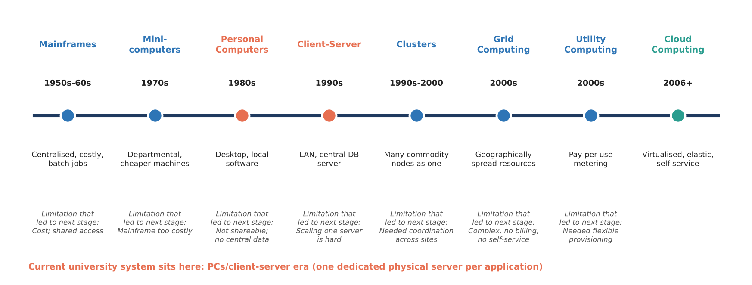
Figure 1: Evolution of computing infrastructure from mainframes to cloud, showing the limitation that led to each next stage
Table 5: Stage-by-stage evolution and the limitation each stage solved
Stage | Key idea | Limitation of the previous stage it solved
Mainframes (1950s–60s) | Large centralised machine; users on terminals; batch processing | First practical shared computing, but extremely expensive and located in one place
Minicomputers (1970s) | Smaller, cheaper machines for departments | Solved the cost and access problem of mainframes; still isolated systems
Personal computers (1980s) | Each user owns a computer and runs local software | Gave individual control and low cost; data and software were not shared
Client–server (1990s) | Clients request services from central servers over a LAN | Restored sharing of data and applications; scaling meant buying a bigger server
Clusters (1990s–2000) | Many commodity machines act as one system | Provided scalability and fault tolerance using cheap hardware, within one site
Grid computing (2000s) | Resources from many sites combined for large problems | Extended pooling across organisations; complex to use, no metering or self-service
Utility computing (2000s) | Computing sold like electricity: metered, pay-per-use | Added billing and on-demand access; lacked flexible, automated provisioning
Cloud computing (2006+) | Virtualised, elastic, self-service, API-driven pools of resources | Combines pooling, metering and automation into a service anyone can consume

2.2 Hardware Evolution that Enabled the Cloud
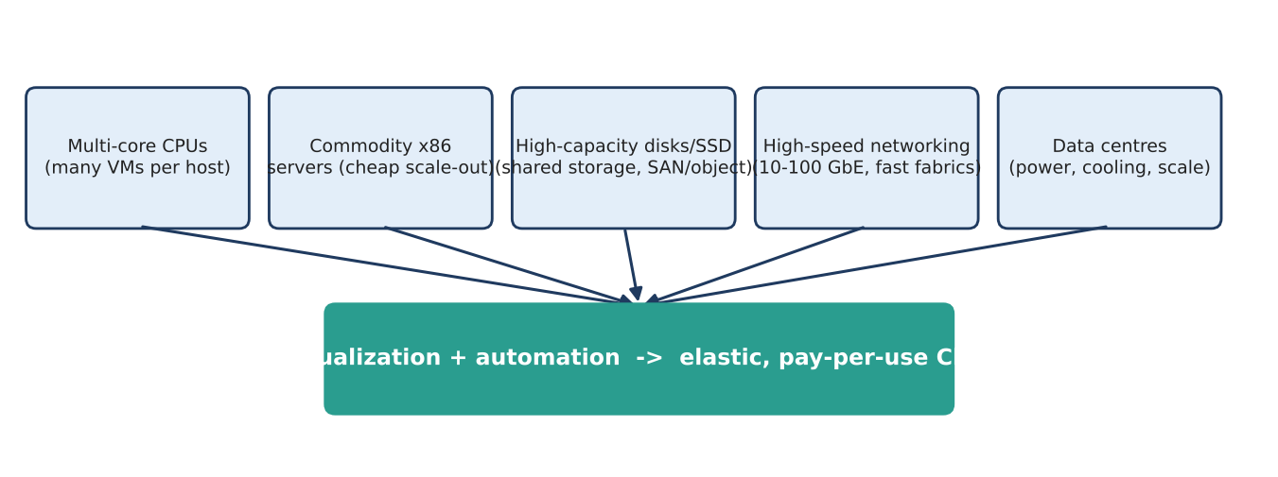
Figure 2: Hardware advances that made large-scale cloud computing economical
- Multi-core processors: many cores per chip allow many virtual machines on one host and make virtualization efficient (hardware-assisted virtualization such as Intel VT-x and AMD-V).
- Commodity servers: inexpensive standard x86 machines replaced costly proprietary systems; scale comes from adding many cheap nodes and tolerating failures in software.
- High-capacity storage: large disks and SSDs, shared network storage (SAN/NAS) and object storage allow VM images, databases and backups to live apart from compute and to be replicated.
- High-speed networking: 10–100 Gb Ethernet and fast fabrics make remote storage and distributed applications perform acceptably and let users reach services over the internet.
- Data centres: purpose-built facilities with shared power, cooling and automation give economies of scale that individual universities cannot match.

2.3 Where the University's Current System Sits
The university's present system corresponds to the PC / client–server era with physical-server silos. The reasons are: (1) each application has its own dedicated physical server (one workload, one machine); (2) there is no virtualization or pooling, so capacity cannot be shared (average 15% utilisation); (3) capacity is fixed and procured manually (6–8 weeks), so there is no elasticity or metering; (4) the applications are large monolithic programs with no public interfaces, which is typical of client–server design; and (5) a single data centre without DR reflects the pre-cluster, pre-cloud single-site model. The migration therefore skips the intermediate stages and moves directly to the virtualised, elastic cloud stage.
Evidence: Labelled timeline (Section 2.1), hardware-enablers diagram (Section 2.2) and a justified placement of the university in the client–server stage.

TASK 3 – Analyse Internet Software Evolution (3 Marks)

3.1 Evolution from Static Pages to Cloud-Hosted Applications
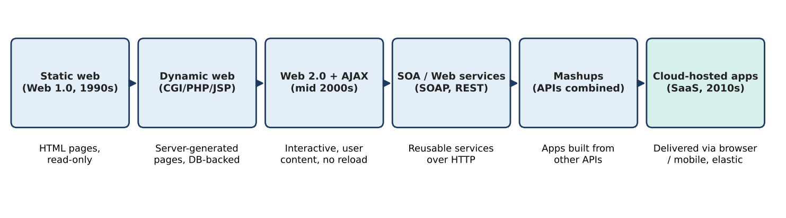
Figure 3: Evolution of internet software towards cloud-hosted applications
Table 6: Stages of internet software evolution
Stage | Characteristics | Contribution to the cloud
Static web (Web 1.0) | Fixed HTML pages served by a web server; read-only | Established HTTP/URLs and the browser as a universal client
Dynamic web | Server-side scripts (CGI, PHP, JSP, ASP) generate pages from a database | Web became an application platform with business logic and data
Web 2.0 | Rich, interactive, user-generated content using AJAX, social platforms | Browser applications comparable to desktop software
SOA | Business functions packaged as loosely coupled services with published interfaces (SOAP/REST) | Reusable, network-callable services: the architectural basis of cloud services
Mashups | Applications assembled from several public APIs (maps + data + payments) | Showed the value of open APIs; a model for partner and mobile integration
Cloud-hosted applications | Applications delivered as SaaS/PaaS, elastic and metered | Software becomes a service rather than a product to install

3.2 Role of Browsers, HTTP, AJAX and APIs
- Browser: a universal, installation-free client that renders HTML/CSS/JavaScript; it makes software delivery independent of the user's operating system.
- HTTP/HTTPS: the request–response protocol (GET, POST, PUT, DELETE, status codes) that carries pages and API calls; HTTPS adds encryption.
- AJAX: asynchronous JavaScript lets a page fetch data in the background and update only part of the page, giving a responsive, desktop-like experience without reloading.
- APIs: well-defined interfaces (typically REST/JSON) through which programs, mobile apps and partners use university functions directly.

3.3 Desktop vs Client–Server vs Web-Delivered Software
Table 7: Comparison of software delivery models
Aspect | Desktop software | Client–server software | Web-delivered (cloud) software
Installation | On every PC | Client on each PC, server in the data centre | None; browser or app
Updates | Manual, per machine | Client updates and server updates | Central, instant for all users
Data location | Local PC | Central server | Central, replicated cloud storage
Scalability | None (one user) | Limited by the server | Elastic, scales out horizontally
Access | Single device | Inside the LAN/VPN | Anywhere with internet
Integration | Files only | Proprietary protocols | Open APIs (REST/SOAP)
Cost model | Licence per PC | Server CapEx plus licences | Subscription or pay-per-use

3.4 Effect on the Design of the University's Applications
The existing monolithic applications must change in four ways to benefit from the cloud: (1) expose functions through APIs (result lookup, fee payment, library search) so mobile apps and partner colleges can integrate; (2) separate the tiers (presentation, application, data) and make the application tier stateless so more instances can be added behind a load balancer; (3) move towards services/microservices gradually, beginning with high-demand functions instead of rewriting everything at once; and (4) deliver through the browser and mobile apps with token-based authentication instead of client installation. Commodity functions such as email are better consumed as SaaS than hosted in-house.
Evidence: Comparative stage table (3.1), software-model comparison (3.3) and design implications linked to the SIS, LMS, Library, Exam Portal and Email applications.

TASK 4 – Apply Server Virtualization (5 Marks)

4.1 How a Hypervisor Works; Type-1 and Type-2
A hypervisor (virtual machine monitor) is software that sits between hardware and operating systems. It divides the physical CPU, memory, storage and network of one host into several isolated virtual machines (VMs), each running its own guest OS. The hypervisor schedules virtual CPUs onto physical cores, maps virtual memory to physical memory, emulates or passes through devices, and prevents one VM from reading another's memory. Hardware-assisted extensions (Intel VT-x, AMD-V) let guest code run directly on the CPU, so the overhead is small.
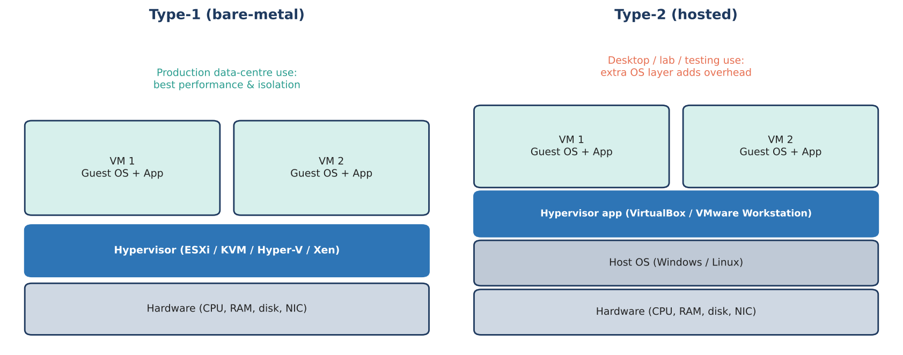
Figure 4: Type-1 (bare-metal) and Type-2 (hosted) hypervisor architectures
Table 8: Type-1 versus Type-2 hypervisors
Feature | Type-1 (bare-metal) | Type-2 (hosted)
Runs on | Directly on hardware | On top of a host operating system
Performance | High, minimal overhead | Lower, due to the extra OS layer
Typical use | Production data centres and cloud | Developer desktops, labs, testing
Examples | VMware ESXi, KVM, Microsoft Hyper-V, Xen | Oracle VirtualBox, VMware Workstation, Parallels
University use | Production hosts for SIS, Exam, LMS | Student labs and PoC (Task 9)

4.2 Virtualization Techniques Compared
Table 9: Full, para-, OS-level and hardware-assisted virtualization
Technique | How it works | Advantages | Disadvantages / Examples
Full virtualization | Hypervisor emulates complete hardware; unmodified guest OS runs | Strong isolation; any OS runs unchanged | Overhead without hardware help. VMware ESXi, KVM
Para-virtualization | Guest OS is modified to make hypercalls to the hypervisor | Lower overhead, better I/O | Needs a modified guest kernel. Xen PV drivers, virtio
OS-level (containers) | Containers share the host kernel, isolated by namespaces/cgroups | Lightweight, start in seconds, high density | Shared kernel means weaker isolation; Linux-on-Linux only. Docker, LXC, Kubernetes pods
Hardware-assisted | CPU extensions (VT-x, AMD-V, EPT) let guests execute directly | Near-native speed; simplifies the hypervisor | Needs supporting CPU. Used by KVM, ESXi, Hyper-V

4.3 Which Applications Run as VMs and Which as Containers
Table 10: Workload placement decision
Application / component | Placement | Reason
Student Information System (SIS) | VM | Legacy monolith with a specific OS/DB stack; holds sensitive personal data; strong isolation and snapshots before upgrades; lift-and-shift without code changes
Exam Portal | VM (initially; auto-scaling group) | Legacy application with strict integrity needs; identical VM images are cloned automatically at peak. Candidate for containers after refactoring
Learning Management System (LMS) | Container | Web application (e.g., Moodle) that is stateless once sessions are externalised; scales horizontally and upgrades easily
Library system | Container | Small, modular web application (e.g., Koha); low resource use; many instances packed per host
New REST APIs (result, fee, library search) | Container | Stateless microservices; fast start and rolling updates; ideal for auto-scaling
Database servers | VM or managed DBaaS | Stateful and I/O-heavy; need consistent storage and backups
Email | Not hosted (SaaS) | Commodity service; vendor operates it (Task 6)

4.4 Consolidation Calculation
Assumptions: (a) the 12 existing servers have equal capacity, which is taken as 1 capacity unit (1 CU) each; (b) average utilisation is 15%; (c) target host utilisation after consolidation is 70% (the remaining 30% is headroom for spikes and hypervisor overhead); (d) hypervisor overhead is covered by the 30% headroom; (e) a new virtualization host is a modern multi-core server, assumed to deliver 4 CU (a conservative assumption for a server several years newer than the ageing ones); (f) peak demand is taken as 95% utilisation.

Step 1 – Total average demand
Average demand = 12 servers x 15% x 1 CU = 1.8 CU

Step 2 – Hosts needed if each new host equals one old server (1 CU)
Usable capacity per host = 1 CU x 70% = 0.70 CU
Hosts = 1.8 / 0.70 = 2.57 -> round up = 3 hosts

Step 3 – Hosts needed with modern hosts (4 CU) – used for the design
Usable capacity per host = 4 CU x 70% = 2.8 CU
Hosts (average load) = 1.8 / 2.8 = 0.64 -> 1 host

Step 4 – Peak-load check (caution)
Worst case, all 12 workloads at 95%: 12 x 0.95 = 11.4 CU
Hosts = 11.4 / 2.8 = 4.07 -> 5 hosts
(with 1-CU hosts it would be 11.4 / 0.7 = 16.3 -> 17 hosts)

Realistic peak, only SIS, LMS and Exam Portal peak at 95%; the other 9 stay at 15%:
Demand = 3 x 0.95 + 9 x 0.15 = 2.85 + 1.35 = 4.2 CU
Hosts = 4.2 / 2.8 = 1.5 -> 2 hosts

Step 5 – Final sizing
For average load one host would suffice (0.64), but one host is a single point of failure. The realistic peak needs 2 hosts at the 70% target. Adding one spare host for N+1 high availability (so that any one host can fail or be maintained while live migration moves its VMs) gives 3 physical hosts, compared with 12 today: a 75% reduction in physical servers. Any demand above the realistic peak (for example, if all applications peak together) is handled by cloud auto-scaling (burst) rather than by buying more hosts. If hosts were equal to the old servers (Step 2), 3 hosts would be needed for the average load and 4 with N+1, which is still a major reduction.
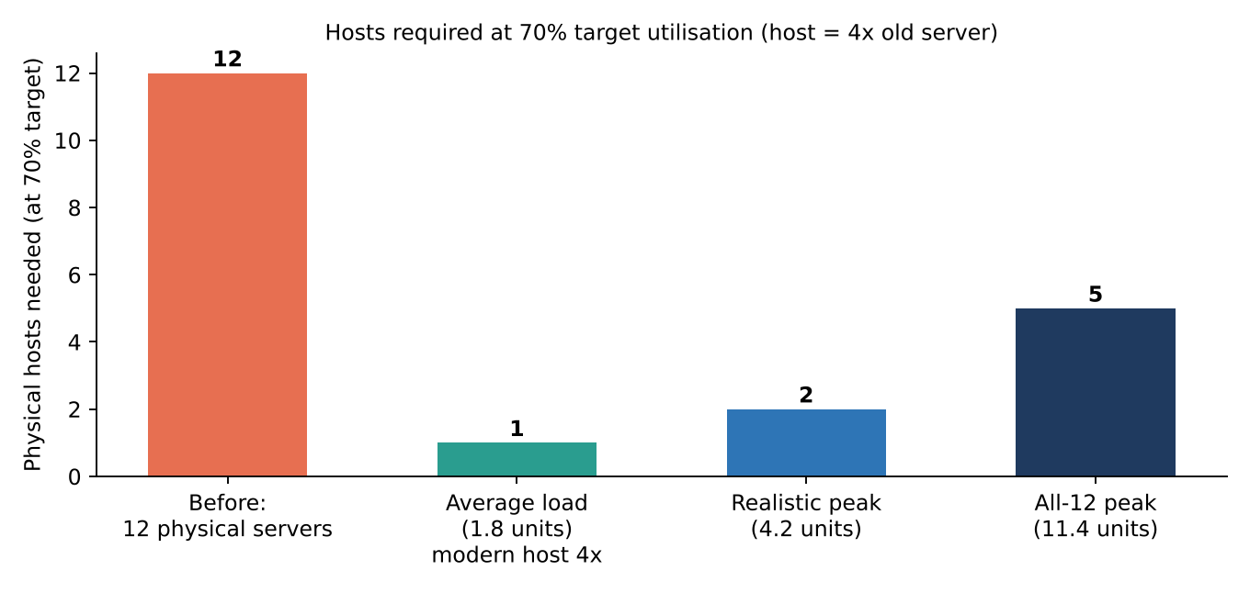
Figure 5: Physical hosts required under the different load cases (host = 4 CU, 70% target utilisation)
Table 11: Summary of consolidation results
Case | Demand (CU) | Host capacity at 70% | Hosts (rounded up)
Average load, 1-CU hosts | 1.8 | 0.7 CU | 3
Average load, 4-CU hosts | 1.8 | 2.8 CU | 1
Realistic peak, 4-CU hosts | 4.2 | 2.8 CU | 2 (+1 spare = 3)
All 12 peak together, 4-CU hosts | 11.4 | 2.8 CU | 5

4.5 Benefits and Risks of Virtualization

Benefits
- Live migration: a running VM moves from one host to another with no noticeable downtime (e.g., VMware vMotion, KVM live migration), enabling hardware maintenance without outage and load balancing across hosts.
- Snapshots: a point-in-time copy of a VM's disk/memory state allows safe upgrades and quick rollback (important before result publication or software patches). Snapshots are not a substitute for backups.
- Resource over-commitment: allocating more virtual CPU/RAM than physically exists works because VMs rarely peak together; it raises utilisation and lowers cost (typical CPU over-commit of 2:1–4:1 for lightly used VMs), but is done carefully for memory and for the Exam Portal.
- Other: faster provisioning from templates, hardware independence, easy DR replication of VM images.

Risks and Mitigations
Table 12: Virtualization risks
Risk | Description | Mitigation
Noisy neighbour | One VM consumes CPU/disk/network and degrades others on the same host | Resource limits, reservations and shares; separate Exam Portal from batch workloads; monitoring
Hypervisor failure | A host or hypervisor fault takes down all VMs on it (bigger blast radius than one server) | Clustered hosts (N+1), HA restart, multi-zone deployment, patched hypervisor
Security isolation | Hypervisor escape or side-channel attacks; misconfigured virtual networks; VM sprawl | Patch promptly, network segmentation/VLANs, least privilege, encrypt VM disks, keep sensitive VMs on dedicated hosts; containers run non-root with image scanning

Evidence: Hypervisor explanation and comparisons (4.1–4.2), placement plan (4.3), worked consolidation calculation with assumptions (4.4) and benefit/risk discussion (4.5).

TASK 5 – Apply Web Services (4 Marks)

5.1 Overview of Web Services; Role in Cloud and SOA
A web service is a software function made available over a network using standard web protocols (HTTP) and data formats (XML or JSON), so that different applications, written in different languages and running on different platforms, can call it. In Service-Oriented Architecture (SOA), an application is built from loosely coupled services, each with a published contract, that are discovered and invoked by consumers. Web services are the integration layer of the cloud: every cloud provider exposes its infrastructure through web APIs, SaaS products integrate through APIs, and load balancers and auto-scaling work best with stateless services. For the university, web services replace the closed monolithic programs with reusable functions that the mobile app, portals and partner colleges can all call.

5.2 Comparison of SOAP, WSDL, UDDI and REST
Table 13: SOAP, WSDL, UDDI and RESTful services
Item | What it is | Format / protocol | Notes
SOAP | Protocol for exchanging structured messages (envelope, header, body) | XML over HTTP/SMTP; usually POST | Standards for security (WS-Security), transactions and reliability; verbose and slower
WSDL | XML description of a SOAP service: operations, messages, endpoints | XML | Machine-readable contract; client code can be generated
UDDI | Registry for publishing and discovering services | XML/SOAP | Rarely used today; replaced by API catalogues/portals
REST | Architectural style: resources identified by URLs, manipulated with standard HTTP methods; stateless | HTTP verbs GET, POST, PUT, DELETE; JSON (or XML) | Lightweight, cacheable, easy for mobile and web; contract described with OpenAPI

Table 14: SOAP versus REST
Criterion | SOAP | REST
Data format | XML only | JSON, XML, others
Message size / speed | Larger, slower | Small, faster
Caching | Not natively | Uses HTTP caching
Security | WS-Security (message-level) | HTTPS + OAuth2/JWT (transport-level)
State | Can be stateful | Stateless (suits auto-scaling)
Best for | Enterprise/bank integrations needing formal contracts and transactions | Web, mobile and public APIs

5.3 University Functions Exposed as Web Services
Four services are defined. Base URL: https://api.university.example/ (placeholder domain). All calls use HTTPS and a bearer token (Authorization: Bearer <JWT>).

Service A – Result lookup (REST)
Table 15: Result lookup API
Item | Definition
Endpoint | /api/v1/results/{reg_no}
Method | GET (read-only, cacheable)
Request | GET /api/v1/results/21CS1001 with the bearer token header
Success response | HTTP 200  {"reg_no":"21CS1001","name":"Anita R","semester":5,"gpa":8.7}
Error response | HTTP 404  {"error":"Student not found","reg_no":"99XX9999"}

Service B – Fee payment (REST)
Table 16: Fee payment API
Item | Definition
Endpoint | /api/v1/fees/pay
Method | POST (creates a payment)
Request | POST /api/v1/fees/pay  Headers: Content-Type: application/json, Idempotency-Key: 7f3c...  Body: {"reg_no":"21CS1001","amount":45000}
Success response | HTTP 201  {"receipt":"RCPT-0001","reg_no":"21CS1001","amount":45000,"status":"SUCCESS"}
Error response | HTTP 400 {"error":"reg_no and amount required"}

Service C – Library catalogue search (REST)
Table 17: Library search API
Item | Definition
Endpoint | /api/v1/library/books?title={text}&page={n}
Method | GET
Request | GET /api/v1/library/books?title=cloud&page=1
Success response | HTTP 200  {"total":2,"items":[{"isbn":"9780134676463","title":"Cloud Computing","copies_available":3}]}
Error response | HTTP 400 for a missing parameter; 429 when the rate limit is exceeded

Service D – Fee reconciliation with the bank / ERP (SOAP)
Table 18: Fee reconciliation SOAP service
Item | Definition
Endpoint | https://api.university.example/ws/FeeReconciliation (WSDL at ?wsdl)
Method | SOAP operation GetSettlementReport over HTTP POST
Sample request | <soap:Envelope xmlns:soap="http://www.w3.org/2003/05/soap-envelope">  <soap:Body>  <GetSettlementReport><Date>2026-11-01</Date></GetSettlementReport>  </soap:Body>  </soap:Envelope>
Sample response | <soap:Envelope ...><soap:Body><SettlementReport>  <Date>2026-11-01</Date><Transactions>1280</Transactions>  <TotalAmount>57600000</TotalAmount></SettlementReport></soap:Body></soap:Envelope>

5.4 SOAP or REST for Each Function
Table 19: Justified choice of style
Function | Choice | Justification
Result lookup | REST | Simple read; heavy read traffic at result publication so HTTP caching/CDN matters; JSON is light for mobile
Fee payment | REST (with HTTPS, OAuth2, idempotency keys) | Mobile app needs a lightweight, fast API; transactional safety is obtained through idempotency keys and the payment gateway, not SOAP; payment-gateway calls follow the gateway's own API
Library search | REST | Public, read-only and cacheable; consumed by web, mobile and partner colleges
Fee reconciliation (bank/ERP) | SOAP | Back-office integration with a formal WSDL contract, WS-Security signing and reliable, auditable exchange that the bank/ERP side already supports

Overall: REST is the default for all user-facing and partner-facing APIs because it is lightweight, stateless and easy to scale; SOAP is retained only where an external enterprise system requires its formal contract and message-level security.
Evidence: Four defined web services with endpoints, methods and sample requests/responses (Section 5.3), a technology comparison (SOAP/WSDL/UDDI/REST and SOAP vs REST tables) and a justified SOAP/REST choice for each function (Section 5.4). A working version of the result-lookup and fee-payment services is implemented in Task 9.

TASK 6 – Analyse the Service Models: IaaS, PaaS and SaaS (5 Marks)

6.1 Definitions and Layer-Wise Responsibility
- IaaS (Infrastructure as a Service): the provider supplies virtualised compute, storage and networking; the customer installs and manages OS, middleware and applications. Example use: virtual machines.
- PaaS (Platform as a Service): the provider also manages OS, runtime and middleware; the customer deploys application code and data. Example use: managed web-app hosting, managed databases, container platforms.
- SaaS (Software as a Service): the provider runs the complete application; the customer only uses it and configures it. Example use: hosted email.
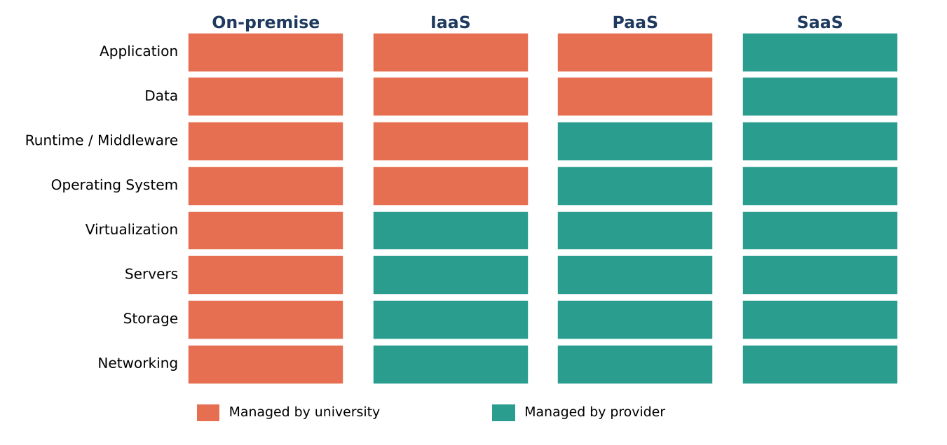
Figure 6: Responsibility by layer: on-premise, IaaS, PaaS and SaaS (orange = university, green = provider)
Table 20: Who manages which layer
Layer | On-premise | IaaS | PaaS | SaaS
Application | University | University | University | Provider
Data | University | University | University | Provider (customer owns the data)
Runtime / middleware | University | University | Provider | Provider
Operating system | University | University | Provider | Provider
Virtualization | University | Provider | Provider | Provider
Servers | University | Provider | Provider | Provider
Storage | University | Provider | Provider | Provider
Networking | University | Provider | Provider | Provider

6.2 Categorisation of the Five Applications with Reasoning
Table 21: Application-to-service-model mapping
Application | Service model | Provider-managed examples
Student Information System (SIS) | IaaS (VMs); later move parts to PaaS | Virtual machines + managed database
Learning Management System (LMS) | PaaS (containers on a managed platform) | Managed container service
Library system | PaaS (container + managed DB) | Managed app hosting
Exam Portal | IaaS (auto-scaling VM group), with API front end on PaaS | VM scale sets + load balancer
Email | SaaS | Hosted email suite

Reasoning behind each decision
- SIS – IaaS. The SIS is a large, customised monolith with a particular OS/database stack and holds the most sensitive data. It cannot run on a PaaS runtime without being re-engineered, so the fastest safe move is lift-and-shift to VMs, which keeps full control of the OS, database tuning and security configuration. The trade-off is that the university still patches the OS and database. Over time, the database moves to a managed database (PaaS) and new functions are exposed as PaaS APIs.
- LMS – PaaS. The LMS (e.g., Moodle) is a standard web application with predictable runtime needs. It can be packaged as a container and run on a managed platform that handles OS patching, scaling and load balancing. This gives elasticity during online-course peaks without server management, while keeping the freedom to customise plug-ins that a pure SaaS LMS would restrict. A fully hosted SaaS LMS is an acceptable alternative if customisation is not needed.
- Library system – PaaS. A small, low-traffic, open-source application. A managed container/app platform with a managed database gives minimal operating effort and low, usage-based cost. IaaS would waste administrator time on a low-value system; SaaS would limit integration with the SIS.
- Exam Portal – IaaS. The Exam Portal needs the most predictable, high-concurrency performance and strict integrity. IaaS provides control over instance size, placement, network isolation and an auto-scaling group of identical VMs that can be pre-scaled before an exam. The public-facing question/answer submission API can be placed behind the PaaS API gateway. Control matters more than convenience for this workload.
- Email – SaaS. Email is a commodity function with no university-specific logic. A SaaS suite gives high availability, spam filtering, storage and security without operating mail servers, and releases a physical server. Vendor lock-in is low because mailboxes can be exported with standard protocols (IMAP).

6.3 Comparison of the Models
Table 22: IaaS vs PaaS vs SaaS
Criterion | IaaS | PaaS | SaaS
Control | High (OS and above) | Medium (application and data) | Low (configuration only)
Cost | Pay for VMs; admin cost remains | Higher unit price, lower admin cost | Per-user subscription; lowest admin cost
Scalability | Manual or auto-scaled VM groups | Automatic and fine-grained | Provider-managed
Maintenance effort | High (OS patches, middleware) | Low-medium (code and data only) | Very low
Vendor lock-in | Low-medium (VMs are portable) | Medium-high (platform-specific services) | High (data format and features)
Best for | Legacy/custom workloads | New web apps, APIs, databases | Commodity business functions

6.4 Real Provider Examples
Table 23: Providers by service model
Model | Example providers
IaaS | Amazon EC2 (AWS), Microsoft Azure Virtual Machines, Google Compute Engine
PaaS | Google App Engine / Cloud Run, Azure App Service, AWS Elastic Beanstalk, Heroku
SaaS | Google Workspace, Microsoft 365 (email), Salesforce, Canvas LMS

Evidence: Layer-wise responsibility figure and table (Section 6.1), five-application mapping with a reasoned justification for every decision (Section 6.2), model comparison (Section 6.3) and provider examples (Section 6.4).

TASK 7 – Examine XaaS (3 Marks)

7.1 What is XaaS and Its Variants
XaaS (Anything-as-a-Service) is the generalisation of the cloud service idea: any IT capability – not only servers, platforms and software – can be delivered over the network, on demand and billed by use. It lets the university buy outcomes (a database, a backup, security monitoring) instead of building and running them.
Table 24: Selected XaaS variants
Variant | What the provider delivers | University use case | Example
DaaS (Desktop as a Service) | Virtual desktops streamed to any device | Computer-lab desktops and remote staff access | Azure Virtual Desktop, Amazon WorkSpaces
BaaS / MBaaS | Ready-made backend (authentication, push, storage) for apps | Backend for the new mobile app | Firebase, AWS Amplify
FaaS (serverless) | Run individual functions on events, billed per execution | Generate result PDFs and send notifications on result publication | AWS Lambda, Azure Functions
DBaaS | Managed database with backup, patching and replication | SIS and fee databases | Amazon RDS, Azure SQL, Cloud SQL
Security-as-a-Service | Cloud-delivered firewall, WAF, identity, threat monitoring | Protect public APIs and student data | Cloudflare WAF, Azure Defender
DRaaS | Replication and failover of servers/data to a provider site | Disaster recovery without a second data centre | Azure Site Recovery, AWS Elastic Disaster Recovery

7.2 Two Selected Offerings and Justification
Selection 1 – DBaaS. The SIS, fee and library data are the most valuable and most failure-sensitive assets. A managed database provides automatic backups with point-in-time recovery, patching, multi-zone replicas and monitoring, which removes the most demanding administration task from a small IT team. It improves availability (automatic failover), manageability (no database patching) and cost (no dedicated DBA hardware), and scales storage as the 40-college load arrives. Risk is moderate, since standard SQL engines (PostgreSQL/MySQL) keep migration possible.
Selection 2 – DRaaS. The university has no disaster-recovery site today, and building one would double CapEx. DRaaS replicates VMs and data to the provider's second region and charges mainly for storage until a failover is needed, so a DR capability costs a small fraction of a second data centre. It directly addresses the missing DR (Task 1, problem 3) and the 99.9% availability requirement in Task 11 (target RTO about 1 hour, RPO about 5 minutes).
FaaS is a strong third candidate for peak events, and is used in the revised design (Task 11).

7.3 Risks of Over-Reliance on Multiple "as-a-Service" Providers
- Vendor lock-in and fragmentation: each provider has proprietary APIs and formats; switching is costly.
- Integration and complexity: many services from many vendors cause identity, networking and monitoring gaps; failures are harder to diagnose.
- Cascading outages and dependency: the university's availability is bounded by the combined availability of all providers (multiplied, not averaged).
- Security and privacy: data spreads across providers; a shared-responsibility misunderstanding can leave gaps; compliance becomes harder to audit.
- Cost creep and billing complexity: many small pay-per-use items are difficult to forecast and govern.
- Skills and contract risk: staff need to learn several platforms; SLAs, exit clauses and data-portability terms differ.
Mitigation: limit the number of providers, prefer open standards (PostgreSQL, containers, OpenAPI), keep exportable backups, define exit plans, use one identity provider, and monitor cost and SLAs centrally.
Evidence: Six XaaS variants explained (Section 7.1), DBaaS and DRaaS selected and justified (Section 7.2), and the risks of over-reliance with mitigation (Section 7.3).

TASK 8 – Design the Cloud Solution Architecture (5 Marks)

8.1 Architecture Diagram
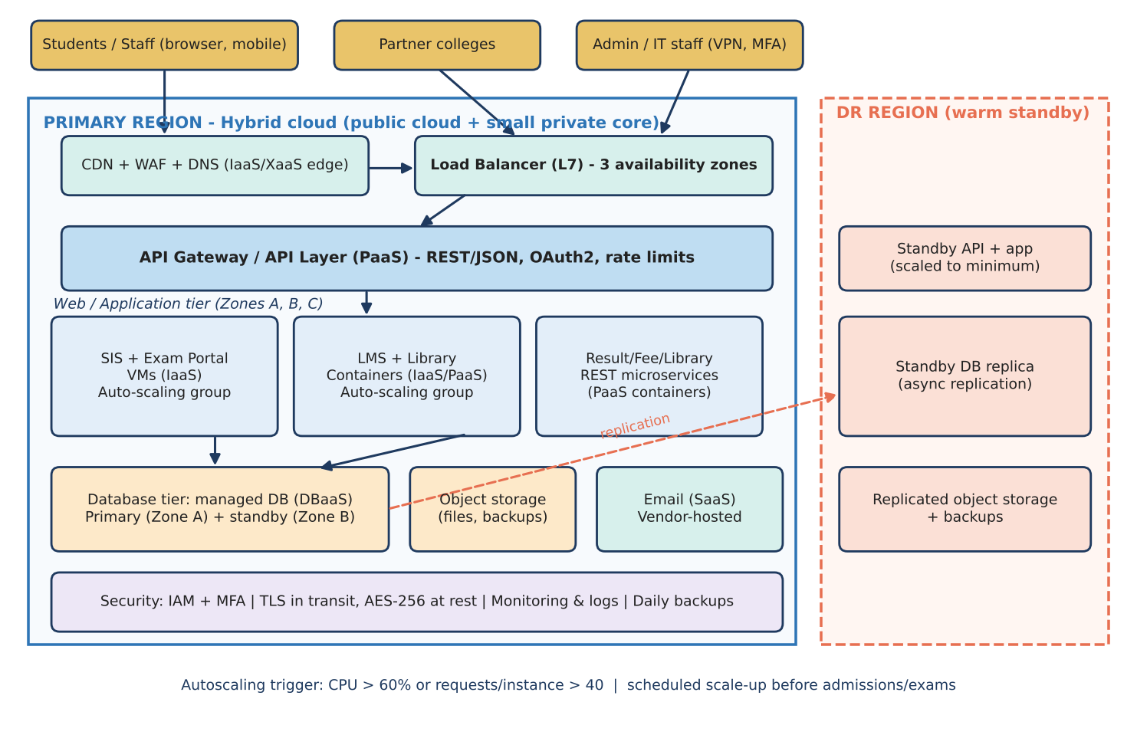
Figure 7: Proposed cloud architecture: hybrid deployment with three availability zones and a warm-standby DR region

8.2 Deployment and Service Model for Each Component
Table 25: Component, deployment model, service model and justification
Component | Deployment | Service model | Justification
Users, partner colleges, IT staff | Internet / VPN | – | Broad network access; staff reach the management plane only through VPN + MFA
CDN + WAF + DNS | Public | IaaS / Security-as-a-Service | Absorbs traffic spikes, caches static content and results, blocks common attacks
Load balancer (L7) | Public | IaaS | Spreads requests over three availability zones; health checks remove failed instances
API layer (API gateway) | Public | PaaS | Single secured entry for mobile/partner access: authentication, throttling, versioning
SIS and Exam Portal | Public cloud, private VPC subnets | IaaS (VMs in auto-scaling groups) | Legacy monoliths; full control; lift-and-shift
LMS and Library | Public cloud | PaaS (managed containers) | Stateless web apps; elastic; low administration
REST microservices (results, fees, library search) | Public cloud | PaaS (containers) | New services; fast to scale and deploy
Database tier | Public cloud, private subnet | DBaaS (PaaS) | Managed backups, patching, primary + standby in different zones
Object storage | Public cloud | IaaS (storage) | Durable, cheap storage for documents, exam files and backups; versioning enabled
Email | Provider-operated | SaaS | Commodity service; no servers to maintain
Identity directory + local backup copy | Private (on-premise) | Private cloud | Keeps sensitive identity data and an offline backup under university control (hybrid model)
DR region | Public cloud, second region | DRaaS / IaaS | Warm standby: minimum capacity, replicated data; scaled up on failover

8.3 Elasticity and Auto-Scaling for Admissions and Exam Peaks
- Reactive scaling: instance groups add instances when average CPU exceeds 60% or when requests per instance exceed about 40; they remove instances after a cool-down (for example 10 minutes of low load). Minimum two instances per tier (one per zone) and a maximum cap protect both availability and budget.
- Scheduled scaling: because admissions, result publication and exam dates are known in advance, capacity is raised before the event (for example 1 hour before an exam starts), avoiding the lag of reactive scaling.
- Offloading: the CDN caches results pages and static assets; queues absorb bursts of writes; read-heavy queries use a cache and a database read replica.
- Stateless application tier: sessions are stored in a shared cache or tokens (JWT), so any instance can serve any request.
- Cost control: scale-in after the event, and budget alerts on spending.

8.4 Security and Availability Measures
Table 26: Security and availability controls
Area | Measure
Access control | Identity and Access Management with least privilege; role-based access (student, faculty, admin, partner college); MFA for staff and administrators; OAuth2/JWT for API access
Encryption | TLS 1.2+ in transit; AES-256 encryption at rest for disks, databases and object storage; keys in a managed key service
Network security | Private subnets for application and database; security groups allow only required ports; WAF and DDoS protection; VPN for administration
Backup | Automated daily database snapshots with point-in-time recovery; object versioning; weekly backup copy to the on-premise private store; restore tests each quarter
Multi-zone deployment | Application and database spread over at least two (preferably three) availability zones; database standby in a different zone; health-checked load balancing
Disaster recovery | Warm standby in a second region with asynchronous replication; target RTO 4 hours / RPO 15 minutes for the original design
Monitoring and audit | Central logging, alerts on CPU, errors and latency, audit trail of administrator actions

Evidence: Labelled architecture diagram (Section 8.1), component table with deployment and service models (Section 8.2), auto-scaling policy (8.3) and security/availability measures (8.4).

TASK 9 – Hands-on Implementation and Documentation (4 Marks)

9.1 Proof-of-Concept Overview and Environment
The proof-of-concept implements the result-lookup and fee-payment web services designed in Task 5 as a small Python Flask REST API, packaged as a Docker container image and prepared for deployment to a PaaS (Google Cloud Run free tier). The API was actually run and tested in the working environment used to prepare this report; the outputs and screenshots below are genuine captures of that run.
Table 27: Environment details
Item | Value
Operating system | Linux (cloud workspace)
Language / framework | Python 3.13, Flask 3.1.3
Server | Flask/Werkzeug development server on port 5000 (gunicorn in the container)
Test clients | curl and a web browser (Chromium)
Container tooling | Docker (Dockerfile provided; see 9.6 for status)
Test date | 2 November 2026

9.2 Source Code

app.py – REST API
from flask import Flask, jsonify, request

app = Flask(__name__)

# Sample in-memory data (a real system would use a managed DBaaS)
RESULTS = {
"21CS1001": {"name": "Anita R", "semester": 5, "gpa": 8.7},
"21CS1002": {"name": "Karthik S", "semester": 5, "gpa": 7.9},
}

@app.route("/health")
def health():
return jsonify(status="UP")

@app.route("/api/v1/results/<reg_no>", methods=["GET"])
def get_result(reg_no):
rec = RESULTS.get(reg_no)
if rec is None:
return jsonify(error="Student not found", reg_no=reg_no), 404
return jsonify(reg_no=reg_no, **rec)

@app.route("/api/v1/fees/pay", methods=["POST"])
def pay_fee():
body = request.get_json(silent=True) or {}
if not {"reg_no", "amount"} <= body.keys():
return jsonify(error="reg_no and amount required"), 400
return jsonify(receipt="RCPT-0001", reg_no=body["reg_no"],
amount=body["amount"], status="SUCCESS"), 201

if __name__ == "__main__":
app.run(host="0.0.0.0", port=5000)

requirements.txt
flask==3.1.3
gunicorn==22.0.0

Dockerfile
FROM python:3.12-slim
WORKDIR /app
COPY requirements.txt .
RUN pip install --no-cache-dir -r requirements.txt
COPY app.py .
EXPOSE 5000
CMD ["gunicorn", "-b", "0.0.0.0:5000", "app:app"]

9.3 Configuration and Reproduction Steps

A. Run locally (executed)
- Create a folder and save app.py and requirements.txt in it.
- Install dependencies: pip install -r requirements.txt (or pip install flask).
- Start the service: python3 app.py – the server listens on port 5000.
- In another terminal, run the curl tests listed in 9.4.

B. Build and run as a container (virtualization – Docker)
docker build -t uni-api:1.0 .
docker run -d --name uni-api -p 5000:5000 uni-api:1.0
docker ps # shows the running container
curl http://localhost:5000/health

C. Deploy to a PaaS (Google Cloud Run free tier)
gcloud auth login
gcloud config set project <PROJECT_ID>
gcloud run deploy uni-api --source . --region asia-south1 --allow-unauthenticated
# the command prints the public service URL, e.g. https://uni-api-xxxx-el.a.run.app
curl https://uni-api-xxxx-el.a.run.app/api/v1/results/21CS1001

Cloud Run is a PaaS: the provider builds the image, runs it, scales it automatically (including to zero) and provides HTTPS. A static site on Firebase Hosting or GitHub Pages, or a managed database on a free tier, can be used as the SaaS/PaaS component in the same way.

9.4 Tests and Recorded Output
Table 28: Test cases and results (actual execution)
# | Test | Command | Expected | Actual
1 | Health check | curl -i localhost:5000/health | 200, {"status":"UP"} | HTTP 200, {"status":"UP"} – PASS
2 | Functional test: valid result | curl -i localhost:5000/api/v1/results/21CS1001 | 200 and JSON record | HTTP 200, {"gpa":8.7,"name":"Anita R","reg_no":"21CS1001","semester":5} – PASS
3 | Failure case: unknown student | curl -i localhost:5000/api/v1/results/99XX9999 | 404 and error JSON | HTTP 404 NOT FOUND, {"error":"Student not found","reg_no":"99XX9999"} – PASS
4 | Fee payment (POST) | curl -i -X POST -H "Content-Type: application/json" -d '{"reg_no":"21CS1001","amount":45000}' localhost:5000/api/v1/fees/pay | 201 and receipt | HTTP 201 CREATED, {"amount":45000,"receipt":"RCPT-0001","reg_no":"21CS1001","status":"SUCCESS"} – PASS

9.5 Annotated Screenshots
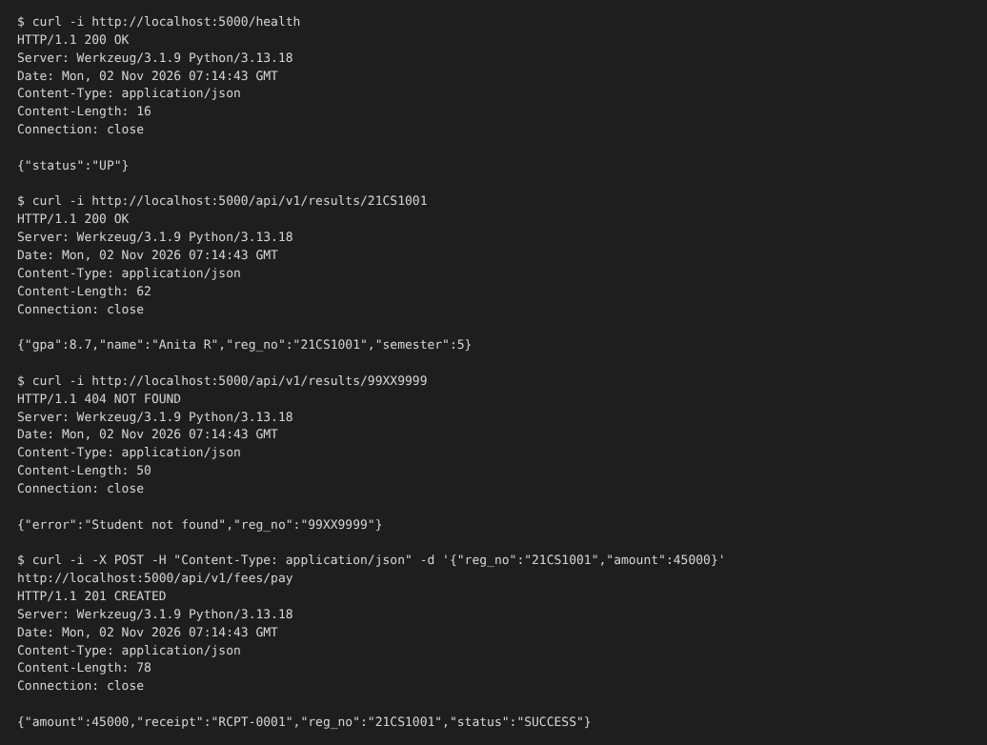
Figure 8: Terminal capture of the curl tests: health check (200), valid result (200), unknown student (404) and fee payment (201). Each response shows the status line, JSON content type and body.
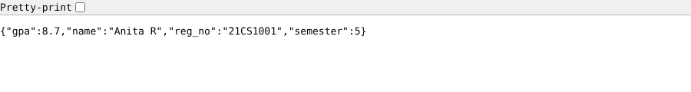
Figure 9: Browser test of `GET /api/v1/results/21CS1001` – the JSON record is returned (HTTP 200).
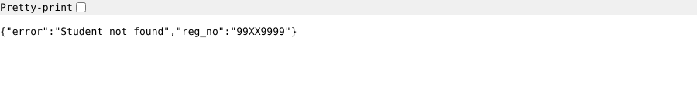
Figure 10: Browser test of `GET /api/v1/results/99XX9999` – the error JSON is returned (HTTP 404).
Annotation: In Figure 8 the $ curl -i lines are the requests; the first line of each response (HTTP/1.1 200 OK, 404 NOT FOUND, 201 CREATED) is the status, Content-Type: application/json confirms the JSON format that Task 5 specified, and the final line is the response body.

9.6 Issues Faced and Evidence Status
- Docker daemon not available in the preparation environment: the container engine could not be started in the cloud workspace used to prepare this report, so docker build/docker run were not executed here. The Dockerfile is provided and uses only standard commands; the same application code was verified by running it directly.
- Cloud deployment not executed: no cloud account is accessible from the workspace, so the Cloud Run deployment in 9.3-C is documented but not verified live.
- Development server warning: Flask's built-in server is for development only; the Dockerfile therefore uses gunicorn.
- Sample data is in memory: a real system would use a managed DBaaS and authentication (OAuth2/JWT) as described in Tasks 5 and 8.
Table 29: Evidence status for Task 9
Item | Status | Note
Source code (Flask API, Dockerfile) | Done | Included above
API run locally and tested with curl/browser | Done | Real outputs and screenshots in 9.4–9.5
Failure case (HTTP 404) | Done | Test 3
Docker container running (docker ps screenshot) | To be captured by the student | Run commands in 9.3-B and insert the screenshot here
PaaS/SaaS deployment URL and screenshot | To be captured by the student | Run 9.3-C or deploy a static site/free database and insert the screenshot here

Evidence: Reproducible source code and steps, executed functional and failure tests with real output and screenshots. The Docker-run and cloud-deployment screenshots must be added from the student's own account (Section 9.6).

TASK 10 – Evaluate and Recommend the Final Solution (7 Marks)

10.1 Comparison of the Three Options
Table 30: On-premise vs IaaS-based vs PaaS/SaaS-based
Criterion | On-premise (refresh) | IaaS-based (lift-and-shift) | PaaS/SaaS-based (re-platform)
Cost: CapEx vs OpEx | High CapEx (new hardware), fixed OpEx | Almost no CapEx; OpEx grows with use | No CapEx; subscription OpEx; some re-engineering cost
Scalability | Fixed; 6–8 weeks to add | Good; auto-scaling VMs, slower to start than containers | Excellent; automatic and fine-grained
Availability | Single site, no DR | Multi-zone and DR possible; university patches OS | Provider-managed redundancy; highest availability
Security | Full control, but university carries all duties and no DR | Shared responsibility; university secures OS and apps | Provider secures platform; university secures data and access
Effort (migration / operations) | Low migration, high operations | Low-medium migration (no code change), medium operations | High migration (refactoring), low operations
Lock-in | None | Low–medium | Medium–high
Fit to the university | Does not solve peaks, DR or APIs | Fast first step for the monoliths | Best end state; not feasible for the monoliths all at once

10.2 Three-Year Cost Comparison
Assumptions (all values in Indian rupees, lakh = 100,000; illustrative planning figures to be replaced by vendor quotations):
- On-premise: hardware refresh of 12 servers at ₹6 lakh each = ₹72 lakh (CapEx in year 1); power, cooling and space ₹12 lakh per year; 4 system administrators at ₹6 lakh per year; licences and annual maintenance ₹10 lakh per year; no DR site.
- IaaS: reserved VMs ₹1.5 lakh per month; peak burst ₹6 lakh per year; storage, backup and DR ₹4 lakh per year; 3 administrators; licences ₹8 lakh per year; one-time migration ₹15 lakh.
- PaaS/SaaS: platform services ₹1.5 lakh per month; SaaS subscriptions ₹12 lakh per year; DR included ₹2 lakh per year; 2 staff (admin + developer); one-time migration and re-engineering ₹30 lakh.
- Hybrid (recommended): IaaS VMs for SIS/Exam ₹0.9 lakh per month; burst ₹5 lakh per year; storage and DR ₹3 lakh per year; PaaS APIs and managed DB ₹0.4 lakh per month; SaaS email/LMS services ₹10 lakh per year; 2 staff; licences ₹4 lakh per year; one-time migration ₹22 lakh.
Table 31: Three-year cost estimate (₹ lakh)
Cost item | On-premise | IaaS | PaaS/SaaS | Hybrid (recommended)
Hardware / compute | 72.0 (hardware) | 54.0 | 54.0 | 32.4 (IaaS VMs)
Peak burst | – (fails at peak) | 18.0 | incl. | 15.0
Power, cooling, space | 36.0 | – | – | –
Storage, backup, DR | – (no DR) | 12.0 | 6.0 | 9.0
PaaS / managed DB / APIs | – | – | – | 14.4
SaaS subscriptions | – | – | 36.0 | 30.0
Staff | 72.0 | 54.0 | 36.0 | 36.0
Licences / maintenance | 30.0 | 24.0 | – | 12.0
Migration (one-time) | – | 15.0 | 30.0 | 22.0
3-year total | 210.0 | 177.0 | 162.0 | 170.8
Average per year | 70.0 | 59.0 | 54.0 | 56.9

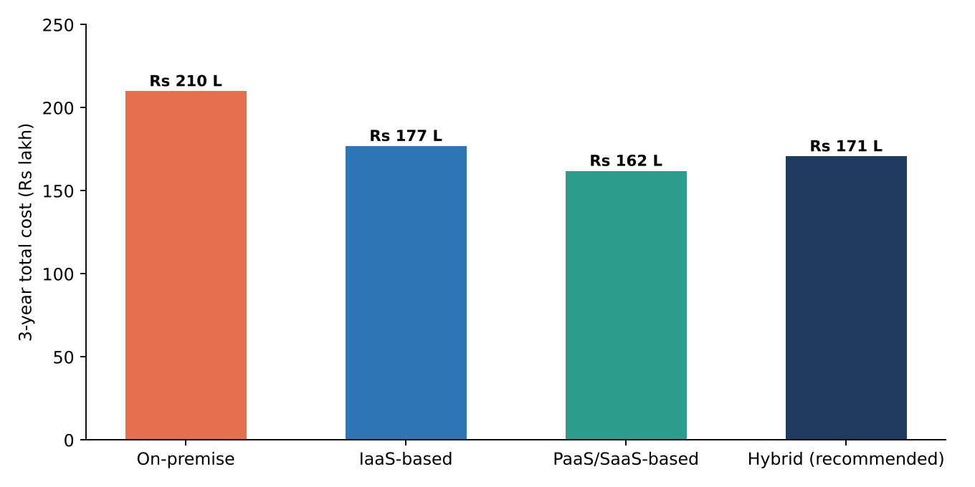
Figure 11: Three-year total cost of ownership by option (₹ lakh, illustrative assumptions)
Interpretation: the hybrid option costs ₹170.8 lakh over three years, which is 19% lower than the on-premise refresh (₹210.0 lakh) and 3.5% lower than pure IaaS, and only ₹8.8 lakh (about 5.4%) above the pure PaaS/SaaS estimate. The small premium over pure PaaS/SaaS is accepted because the monolithic SIS and Exam Portal cannot be re-platformed in one step. Also, the on-premise figure does not buy elasticity or DR, so it is not a like-for-like comparison.

10.3 Main Risks and Mitigation
Table 32: Risk analysis
Risk | Impact on the university | Mitigation
Vendor lock-in | Hard and costly to change provider; price increases | Use open standards (containers, PostgreSQL/MySQL, OpenAPI); avoid proprietary services for core data; keep infrastructure as code; exportable backups; exit clause in the contract
Data privacy and compliance | Student personal and financial data exposed or stored in a disallowed location | Choose an India region for data residency (Digital Personal Data Protection Act, 2023); encryption at rest/in transit; IAM with least privilege; audit logs; data-processing agreement
Downtime | Exam or admission disruption; reputation loss | Multi-zone deployment, DRaaS, health checks, scheduled pre-scaling, tested rollback; freeze changes during exams; SLA review
Skills gap | Misconfiguration, slow migration, cost overrun | Staff training and certification, a pilot project first, managed services to reduce operations, support contract during migration
Cost overrun | Pay-per-use grows unchecked | Budgets and alerts, auto-scale limits, reserved capacity for steady load, monthly cost review
Connectivity dependence | Campuses unable to reach the cloud | Redundant internet links at each campus; CDN caching; offline procedures for exams

10.4 Final Recommendation and Migration Roadmap
Recommendation: a phased hybrid, public-cloud-first solution, not a single-model choice:
- IaaS (VMs in auto-scaling groups) for the SIS and Exam Portal in the first stage, with DBaaS for the databases (lift-and-shift without rewriting).
- PaaS (managed containers) for the LMS, the Library and the new REST APIs behind an API gateway.
- SaaS for email; DBaaS and DRaaS as the selected XaaS offerings (Task 7).
- A small on-premise private core for identity and a backup copy, giving the hybrid deployment model.
Why this and not just a popular provider: the choice follows from the analysis: utilisation of 15% and peaks above 95% (Task 4, 1.8 CU of demand consolidates 12 servers into about 3 hosts), monolithic applications that must first be lifted before being refactored (Tasks 3 and 6), the need for DR and APIs (Tasks 5 and 8), and a three-year cost lower than the alternatives (Table above). The cloud provider is then selected by criteria rather than by popularity: Indian data-centre regions, price for the projected workload, education discounts, managed container/database/DR services, SLA of at least 99.9%, support and exit terms. Two or three providers (for example AWS, Azure, Google Cloud) are to be compared with a proof-of-concept and quotations before signing.
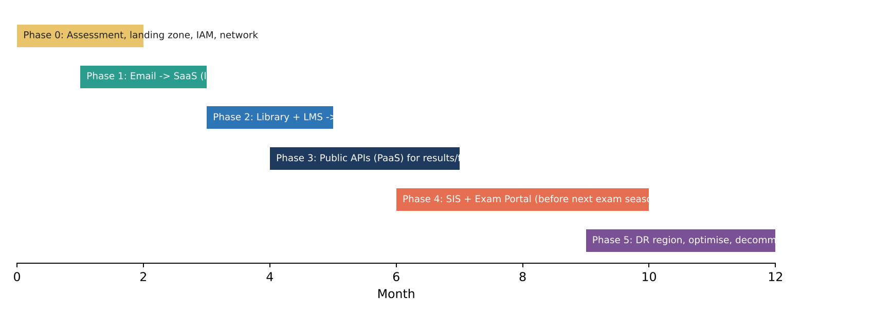
Figure 12: Phased 12-month migration roadmap
Table 33: Migration order and reasons
Order | Application | Reason for this position
0 | Landing zone: network, identity, security, monitoring | Foundation for every workload; trains the team
1 | Email → SaaS | Lowest risk, commodity function, quick visible benefit, releases a server, builds confidence
2 | Library then LMS → containers/PaaS | Moderate risk and standard software; the LMS benefits from elasticity; good learning projects before the critical systems
3 | Public REST APIs for results, fees and library search | New build, no legacy risk; enables the mobile app and partner access (needed in Task 11)
4 | SIS and Exam Portal → IaaS VMs, with DBaaS | Most critical and complex; migrated last, with rehearsals, outside exam periods, and ready before the next exam season
5 | DR region, optimisation and decommissioning old servers | Only after all workloads run in the cloud; reduces cost and finishes the exit from on-premise

Evidence: A three-way comparison (10.1), a three-year cost estimate with stated assumptions (10.2), risks with mitigations (10.3), and a justified recommendation with phased migration roadmap (10.4).

TASK 11 – Day-4 Design Challenge: Re-evaluate and Adapt the Design (8 Marks)
Changed requirement: a mobile app and student-record and fee-payment services opened to 40 affiliated colleges; expected load of 10 times the current peak; 99.9% availability; limited operating budget.
Decision: MODIFY. The core principles of the original design (hybrid cloud, virtualization, API-first and phased migration) are retained, but the compute tier, API layer, database availability and DR are substantially modified, as justified below.

11.1 Impact Analysis (2 Marks)

What has changed
Table 34: Original problem versus the changed problem
Aspect | Original | Now
Users | ~27,000 (25,000 students + 2,000 staff) on 4 campuses | The same, plus mobile users and users of 40 external colleges (several times more)
Access | Campus web portals | Public mobile app and partner APIs over the internet
Peak load | Admissions/exam peaks (≈150 requests/s assumed) | 10× peak ≈ 1,500 requests/s
Availability | Best effort; no DR | 99.9% (≈8.76 hours downtime a year)
Cost | Reduce CapEx | Limited operating budget despite 10× load
Tenants | One organisation | 41 organisations (university + 40 colleges) sharing the service

Original assumptions affected
- Load: the sizing of 2–3 hosts with moderate burst assumed the university's own peaks only; it is now insufficient by an order of magnitude.
- Users: the user population is no longer known or campus-bound; unauthenticated or hostile traffic is possible.
- Availability: a warm-standby DR with RTO 4 h/RPO 15 min and partial multi-zone use does not guarantee 99.9% for payments.
- Cost: the cost model assumed predictable usage; it must now protect the budget while handling spikes.

Why web services and APIs become critical
The mobile app and the colleges' systems cannot use the university's portal screens; they must call stable, secured, versioned APIs. The API layer becomes the product: it provides authentication, per-college authorisation, throttling (so one college cannot starve the others), versioning, monitoring and caching. Poor API design or availability now directly stops fee payment for 40 colleges, so the API gateway and the stateless REST services of Task 5 move from "optional" to "critical path".

Effect of multi-tenant access by 40 colleges on security and isolation
- Data isolation: each college must see only its own students; a single mistake leaks records across institutions (a privacy and legal breach). Isolation is enforced at several levels: tenant ID inside the token (JWT claim), row-level security or schema-per-tenant in the database, and per-tenant encryption keys.
- Authentication and authorisation: OAuth2 with per-college client credentials; role-based scopes; MFA for college administrators.
- Noisy-neighbour control: per-tenant rate limits and quotas at the API gateway.
- Audit and compliance: per-tenant audit logs, data-processing agreements with each college, and breach-notification procedures.
- Larger attack surface: internet-facing APIs need WAF, DDoS protection, input validation and regular security testing.

11.2 Evaluation of the Original Design (2 Marks)

Can the service models and virtualization plan handle 10× load?
Not economically and not reliably. The plan has 3 hosts and VM-based auto-scaling groups. Scale-out of full VMs takes minutes and each VM carries a whole guest OS, so reaching the target needs many VMs. The capacity calculation (Section 11.4) shows that about 36 application instances are needed at 10× peak and about 54 if one availability zone can fail. As always-on VMs this is a large fixed cost; as auto-scaled VMs it reacts slowly to the sudden rise at result publication. The SIS/Exam monoliths scale only vertically or by cloning whole VMs, and the database becomes the bottleneck. Containers and serverless functions scale faster and pack more work per host.

Are auto-scaling and a single-region deployment sufficient for 99.9%?
No. 99.9% allows only 8.76 hours of downtime a year (0.001 × 8,760 h). Auto-scaling protects against load, not against failures. A single region leaves the university exposed to a regional outage, and the original design used a warm-standby DR with a 4-hour recovery time, which on its own would consume half of the annual allowance in a single event. In Section 11.4 the availability calculation shows that a single-zone chain of ordinary components yields about 98.99% (≈88 hours a year), far from the target.

Does cost stay acceptable?
Partly. Scaling the original design to 10× raises the compute bill to about ₹54 lakh a year and the total running cost to about ₹91.0 lakh a year (Section 11.4), without delivering the required availability. The budget is limited, so cost per request must fall rather than grow linearly.

Would another service model or XaaS offering give better results?
- FaaS (serverless) for spike-driven, short tasks (result PDFs, notifications, receipts): pay-per-execution and instant scaling, with no idle cost.
- Managed Kubernetes / container PaaS instead of VMs for the web and API tier: faster scaling, higher density and rolling updates.
- API gateway as a service, CDN and Security-as-a-Service (WAF/DDoS): protect and offload traffic; the CDN absorbs a large share of read requests (results, static content).
- DBaaS with multi-zone failover and cross-region replica, plus DRaaS: higher availability for the least cost of operation.
- BaaS/MBaaS (identity, push notifications) for the mobile app.

11.3 Adaptation or Redesign (2 Marks)

Decision and revised architecture
MODIFY (partial redesign of the application tier). The hybrid deployment, the API-first approach, DBaaS and the phased migration are retained. Changed are the compute model (containers/serverless), the API layer (gateway with tenant control), the availability design (three zones plus a warm DR region) and the cost controls.
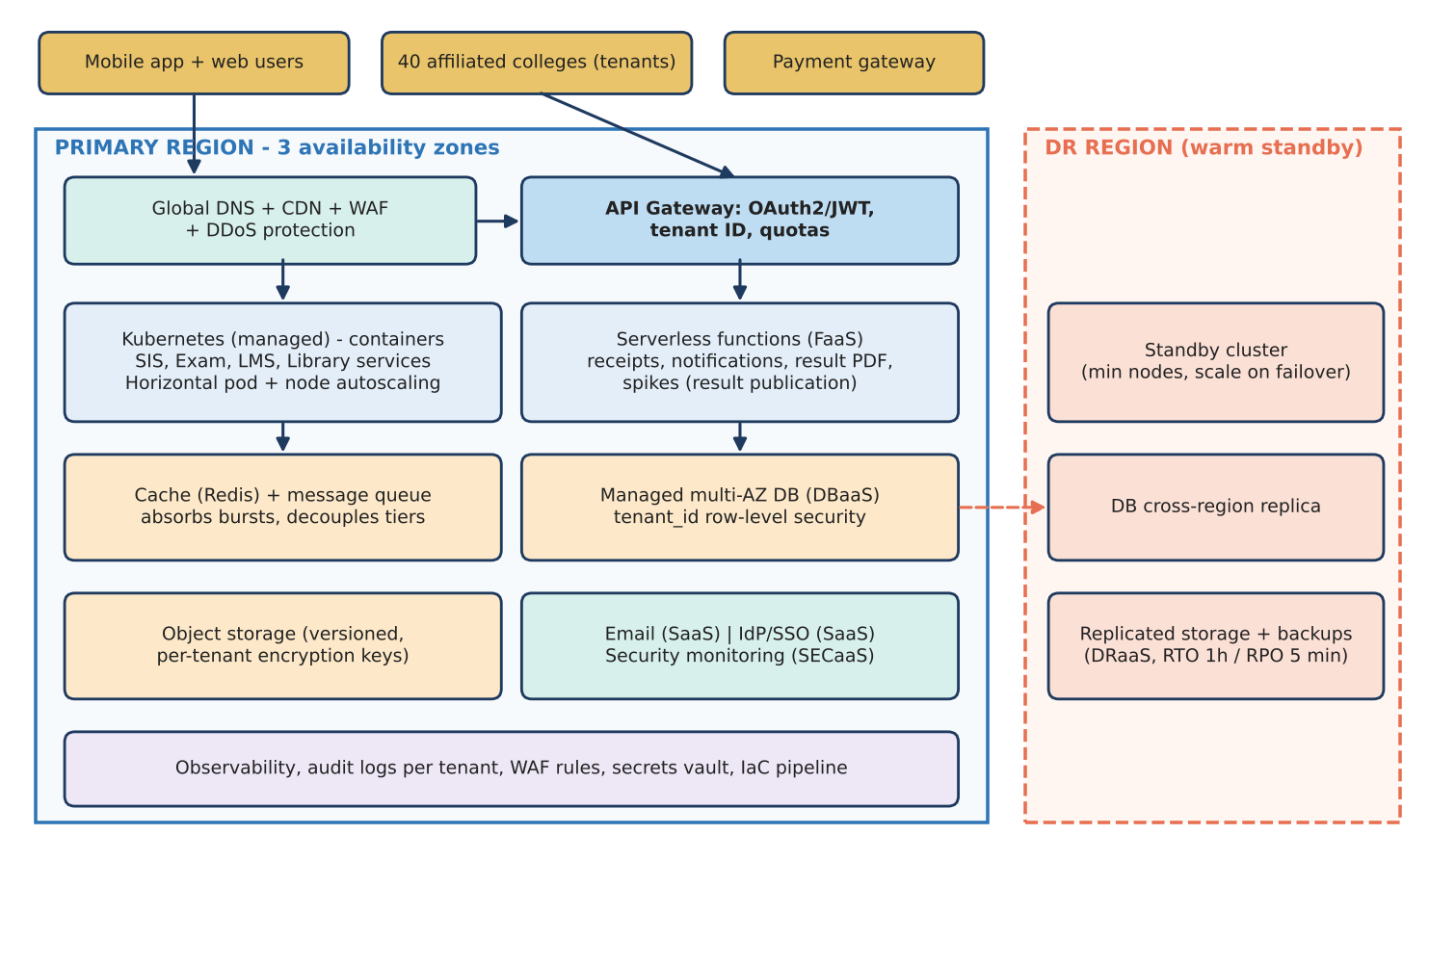
Figure 13: Revised architecture for the mobile app and 40 affiliated colleges: API gateway, managed Kubernetes, serverless functions, cache and queue, multi-AZ database and warm DR region
Table 35: Original versus revised components
Component | Original design | Revised design
Entry point | Load balancer + CDN | Global DNS + CDN + WAF + DDoS protection, then API gateway with OAuth2/JWT, tenant ID and quotas
Application tier | VM auto-scaling groups (SIS, Exam) and containers (LMS, Library) | Managed Kubernetes with pod and node autoscaling for all services; serverless functions for burst tasks; SIS/Exam VMs only for the legacy parts until refactored
Bursts and decoupling | Auto-scaling only | Cache (Redis) and message queue absorb spikes and protect the database
Database | DBaaS, primary + standby | Multi-AZ DBaaS, read replicas, tenant row-level security, cross-region replica
Availability | Multi-zone partly; DR RTO 4 h | Three availability zones; warm DR region, target RTO 1 h / RPO 5 min
Security | IAM, encryption, backups | Adds per-tenant isolation, WAF/DDoS, per-tenant keys and audit, secrets vault
Cost controls | Auto-scale limits | CDN caching, spot/preemptible nodes for stateless pods, reserved capacity for baseline, budgets and per-tenant usage reports

What changed in the service model mix and in the virtualization approach
- Service model mix: from mostly IaaS + PaaS to PaaS (managed Kubernetes, API gateway) + FaaS + DBaaS + SaaS (email, identity) + Security-as-a-Service + DRaaS. IaaS VMs shrink to the legacy SIS/Exam components awaiting refactoring.
- Virtualization approach: from VM-first (hypervisor-based consolidation of 12 servers into 3 hosts) to container-first (OS-level virtualization orchestrated by Kubernetes) on top of provider hypervisors; the VM layer remains for isolation of the legacy SIS and for the managed nodes. Containers start in seconds and pack more workloads per node, which reduces cost at 10× load.
- Not retained as-is: the original reasoning that the load was university-only and could be handled with a small VM pool was rejected; the principles that remain valid are the hybrid model, virtualization, API-first design and phased migration.

11.4 Evidence-Based Defence (2 Marks)

Capacity and availability calculations
Capacity (assumptions: current peak ≈ 150 requests/s; one application container serves ≈ 60 requests/s at full load, i.e. ≈ 42 requests/s at the 70% target utilisation):
New peak = 10 x 150 = 1,500 requests/s
Instances needed = 1,500 / 42 = 35.7 -> 36 instances
Zone-failure tolerance (3 zones, survive the loss of one zone):
each zone must be able to carry 1,500 / 2 = 750 req/s
total = 36 x 3 / 2 = 54 instances (18 per zone)

Caching of results and static content in the CDN (assumed to remove about 60% of read traffic) and serverless offloading reduce the instances that the origin must actually run at most times, so the 54 instances are a ceiling reached only at result publication, not an always-on fleet.
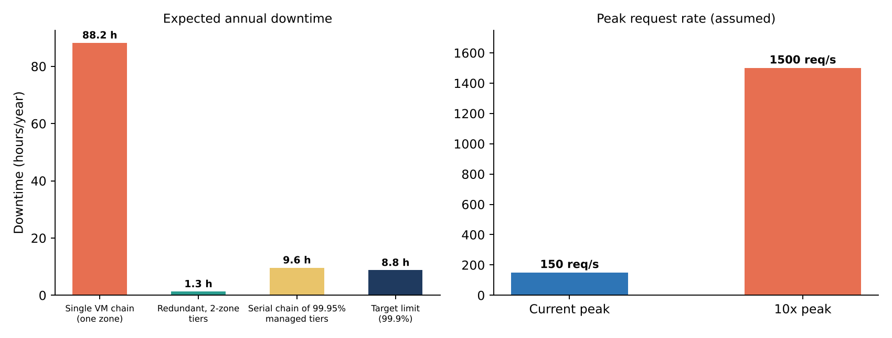
Figure 14: Left: expected annual downtime for different designs against the 99.9% limit. Right: assumed peak request rate before and after the change
Availability (assumptions: load balancer 99.99%; one VM/instance 99.5%; downtime hours per year = (1 − availability) × 8,760):
99.9% target downtime = 0.001 x 8,760 = 8.76 hours per year (99.5% = 43.8 h)

Option A - single zone, one instance per tier (LB -> app -> DB)
A = 0.9999 x 0.995 x 0.995 = 0.9899 (98.99%) -> 88.2 hours/year FAILS

Option B - two zones, each tier duplicated (parallel redundancy)
tier = 1 - (1 - 0.995)^2 = 0.999975
A = 0.9999 x 0.999975 x 0.999975 = 0.99985 (99.985%) -> 1.3 hours/year PASSES

Option C - chain of three managed services each at a 99.95% SLA
A = 0.9999 x 0.9995 x 0.9995 = 0.99890 (99.89%) -> 9.6 hours/year marginal

Option A represents the original design's weak points; Option B shows that duplicating each tier across zones brings the target within reach (the calculation assumes independent failures, so it is a best case). Option C shows that published provider SLAs multiplied in series are marginal on their own, so the revised design does not rely on the SLA alone: it adds zone redundancy, CDN/cache serving of read requests during a backend fault, automated failover for the database, and a warm DR region for regional outages. Availability will be verified by synthetic monitoring and failover drills.

Cost comparison between the original and the revised design
Table 36: Annual running cost at 10× load (₹ lakh per year, illustrative assumptions)
Item | Original design scaled to 10× | Revised design
Compute | 54.0 (VM groups, ≈3× the base ₹1.5 lakh/month average) | 31.2 (containers, spot nodes, serverless; ₹2.6 lakh/month)
CDN, API gateway, WAF | – | 12.0
Managed multi-AZ database | incl. in compute/storage | 12.0
Storage and DR | 6.0 (backup only, no warm DR) | 14.4 (warm standby DR region)
Load balancer / network | 5.0 | incl.
Staff | 18.0 | 15.0 (more managed services)
Licences | 8.0 | 4.0
Total per year | 91.0 | 88.6

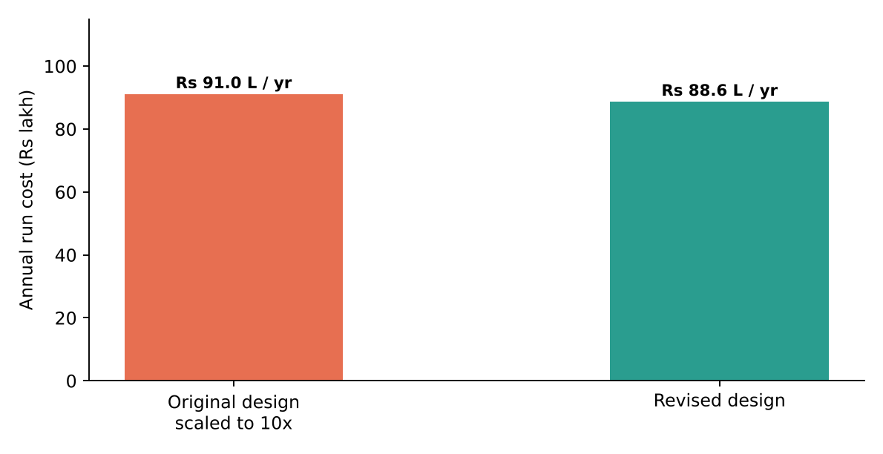
Figure 15: Annual running cost at 10× load: original design scaled up versus revised design (₹ lakh per year)
The revised design costs about ₹88.6 lakh a year compared with ₹91.0 lakh for the scaled original: it is slightly cheaper while also adding a warm DR region, a WAF and zone redundancy that the scaled original lacks. The saving comes from CDN offload, container density, spot capacity and pay-per-execution functions. The figures are planning assumptions and must be confirmed with provider price calculators.

Security and multi-tenancy considerations
- Tenant ID in the JWT is checked at the API gateway and again in the service; database row-level security makes cross-tenant reads impossible even if application code has a bug.
- Per-tenant encryption keys for sensitive fields and objects; per-tenant rate limits and quotas; per-tenant audit logs.
- WAF, DDoS protection, OAuth2 client credentials for colleges, MFA for administrators, regular penetration tests and security monitoring (Security-as-a-Service).
- Because the design is a shared multi-tenant platform rather than 40 separate deployments, cost is lower; highly sensitive colleges may be offered a dedicated database if required.

Trade-offs
Table 37: Trade-offs of the revised design
Trade-off | Effect | Control
Vendor lock-in | Managed Kubernetes, API gateway and FaaS are provider-specific to different degrees | Use standard Kubernetes and containers, OpenAPI, PostgreSQL; keep functions thin; infrastructure as code
Complexity | Kubernetes, queues and multi-region need skilled staff | Managed services, training, runbooks, phased rollout, support contract
Migration effort | Refactoring to containers and APIs and building DR takes time | Phase APIs first (new build), leave the SIS/Exam monoliths on VMs until refactored; pilot with 2–3 colleges before all 40
Cost of availability | Warm DR region and multi-zone cost more than a single zone | Run DR at minimum size; scale only on failover; cost is offset by CDN and spot savings
Eventual consistency | Cross-region replica lags by minutes (RPO ≈ 5 min) | Acceptable for DR; payments use the primary with idempotent writes

Final decision
The original design is modified, not discarded: its hybrid, virtualization and API-first foundations remain, but the application tier moves to containers and serverless functions behind a tenant-aware API gateway, the database and zones are made redundant, and a warm DR region is added. The change follows from the calculations: 36–54 instances at peak, a 99.9% target that needs zone redundancy and automated failover, and a running cost of about ₹88.6 lakh a year, no higher than the original scaled design.
Evidence: Impact analysis, evaluation, retain/modify/redesign decision with revised architecture, and an evidence-based defence with capacity, availability and cost calculations, multi-tenant security and trade-offs (Section 11). The load-test validation of the capacity assumptions is recommended before go-live.

